CST 2309 Lab 2.2

Refer to Tutorial 1: Getting Started with HTML page

1. Complete Session 1.2 pages HTML 22 to HTML 44

Add a screenshot of the **ct_about.html** file displayed in a browser after completing Step 4 on page HTML 38. Include address bar. See Figure 1-25 for reference

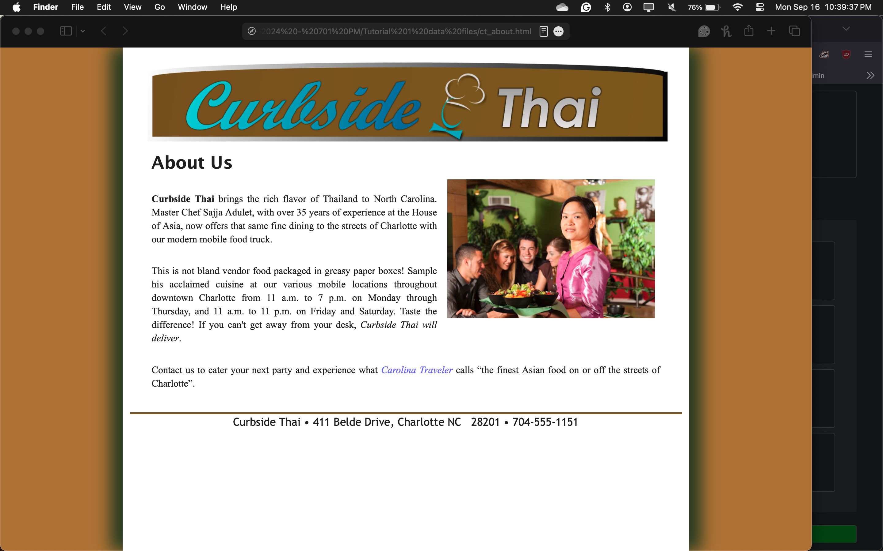

Add a screenshot of the **ct_reviews.html** file displayed in a browser after completing Step 6 on page HTML 40. Include address bar. See Figure 1-27 for reference

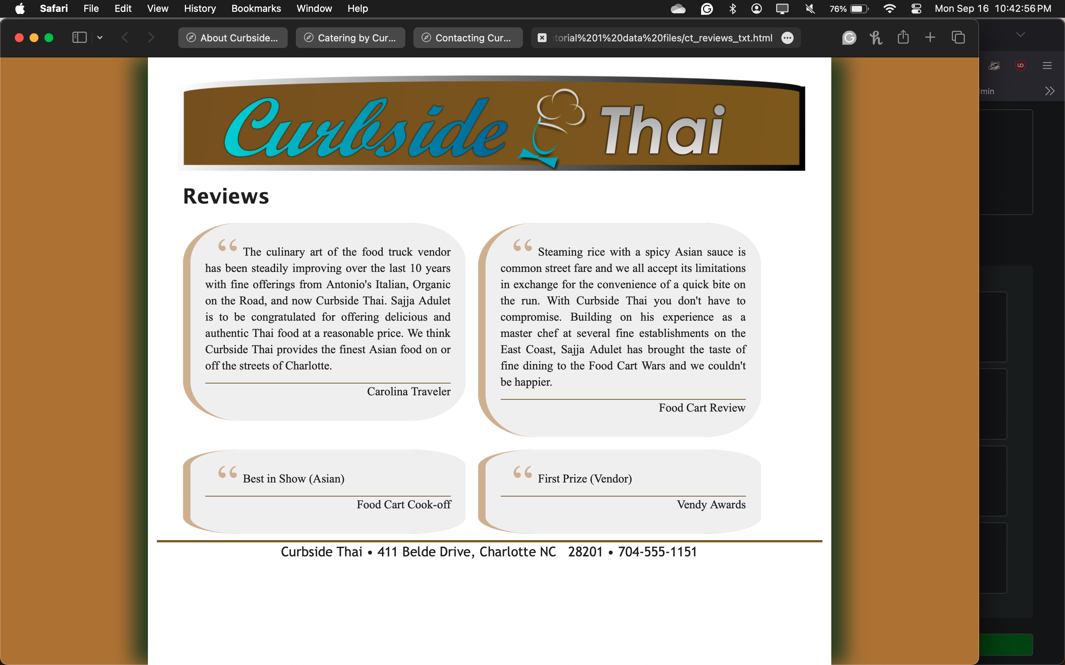

Add a screenshot of the **ct_catering.html** file displayed in a browser after completing Step 7 on page HTML 42. Include address bar. See Figure 1-29 for reference

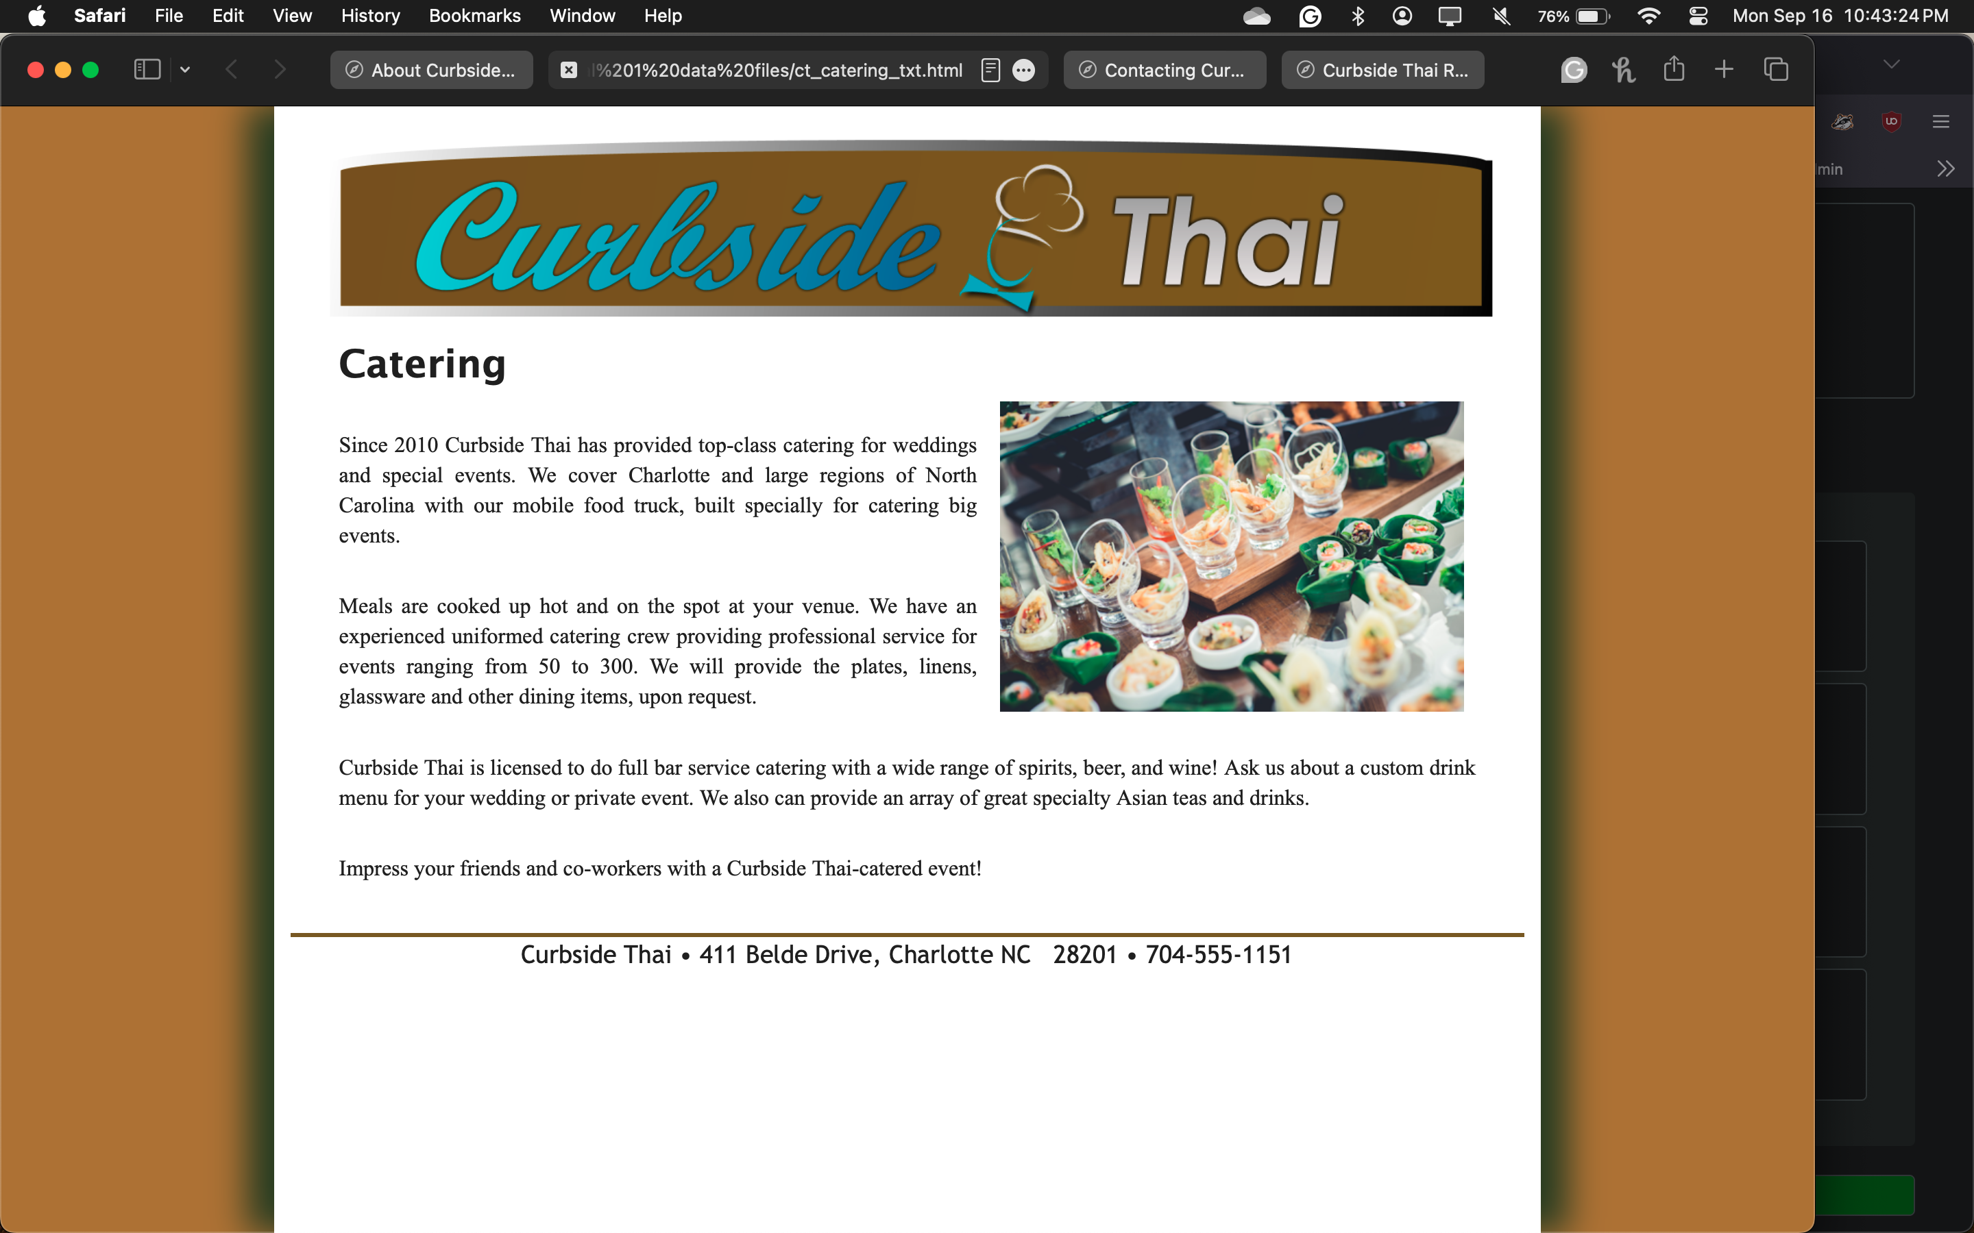

Add a screenshot of the **ct_contact.html** file displayed in a browser after completing Step 8 on page HTML 43. Include address bar. See Figure 1-31 for reference

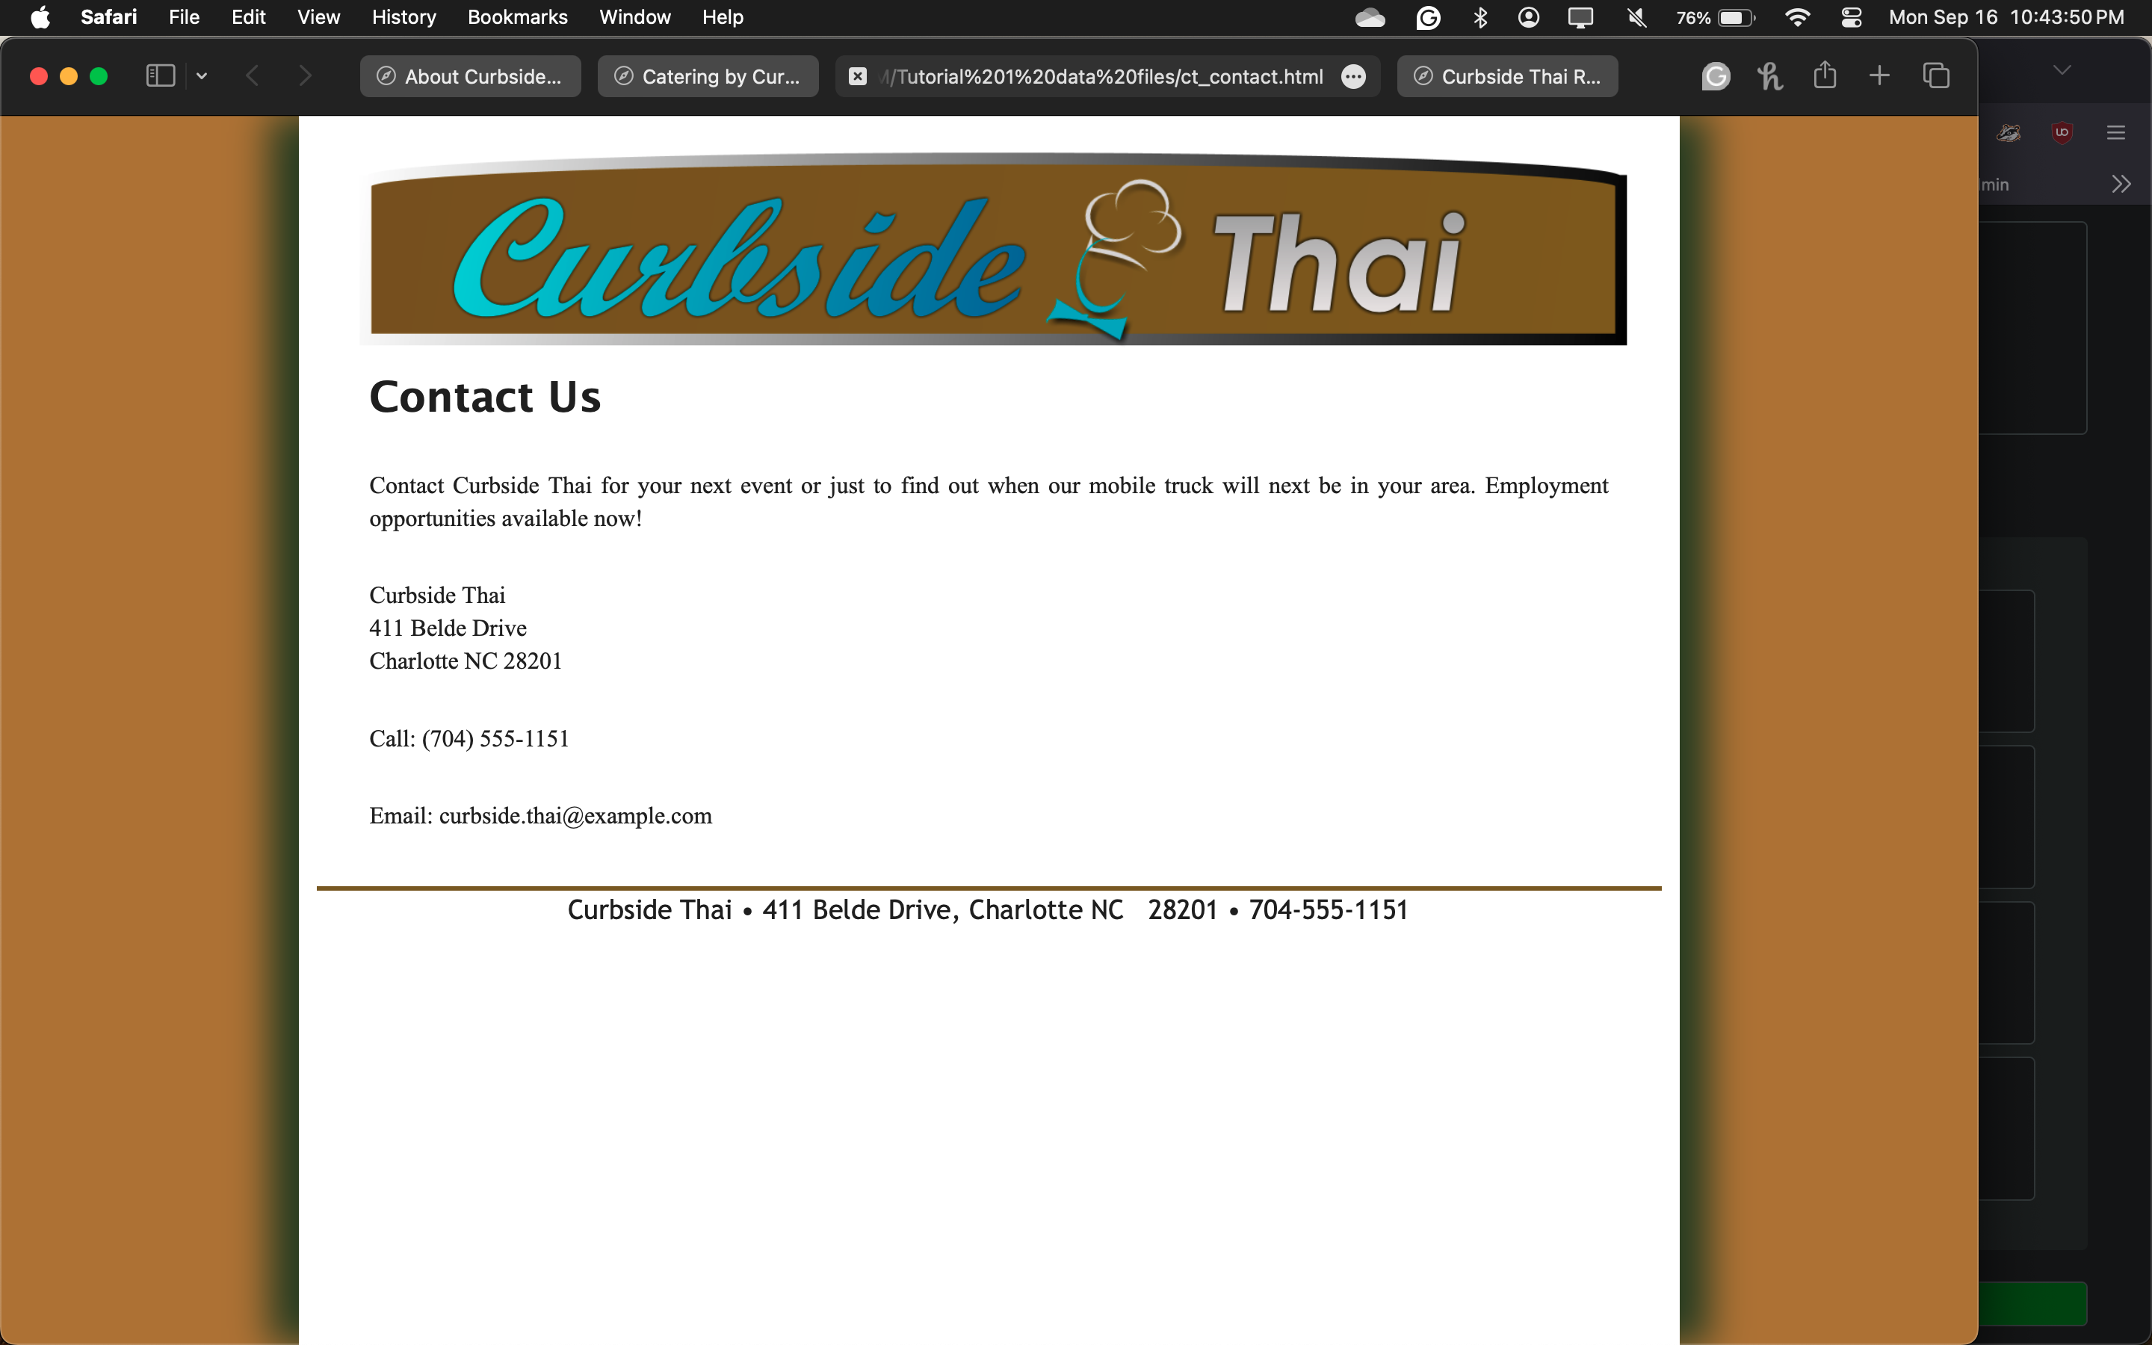

1. Complete Session 1.2 Quick Checks

Completed. I would like to review the answers.